

**Northern Frontier Section of the Green Mountain Club**

**Winter 2024/2025 Newsletter**

Season’s Greetings!

The snowfall so far this winter has been good for the ski areas and looks encouraging for us hikers too. On a snowshoe hike a few weeks ago, I went up the Long Trail toward Jay Peak and measured 2 feet of snow at the higher elevations. The Northern Frontier Section is leading group hikes this season and we hope you’ll come with us on at least one of these outings. Check out the schedule of outings on the last page of this newsletter.

We had a good hiking and trail work season in 2024. Scheduling our activities around rainy weather, trail adopters did walk-throughs, cut blowdowns and cleaned waterbars on the Northern Frontier Section of the LT. In October, a team of four of us reblazed a section of the LT from Jay Peak to Laura Woodward Shelter. By early summer, Bill Haynie and Christian Lakos completed the new tent platform at Jay Camp (with a fire ring nearby). Shelter adopters and volunteers carried bales of wood shavings to their shelters for the moldering privies, did small repairs where needed, cleaned-up and carried out trash. Many Thanks to Bill and Christian for the good work on that platform!

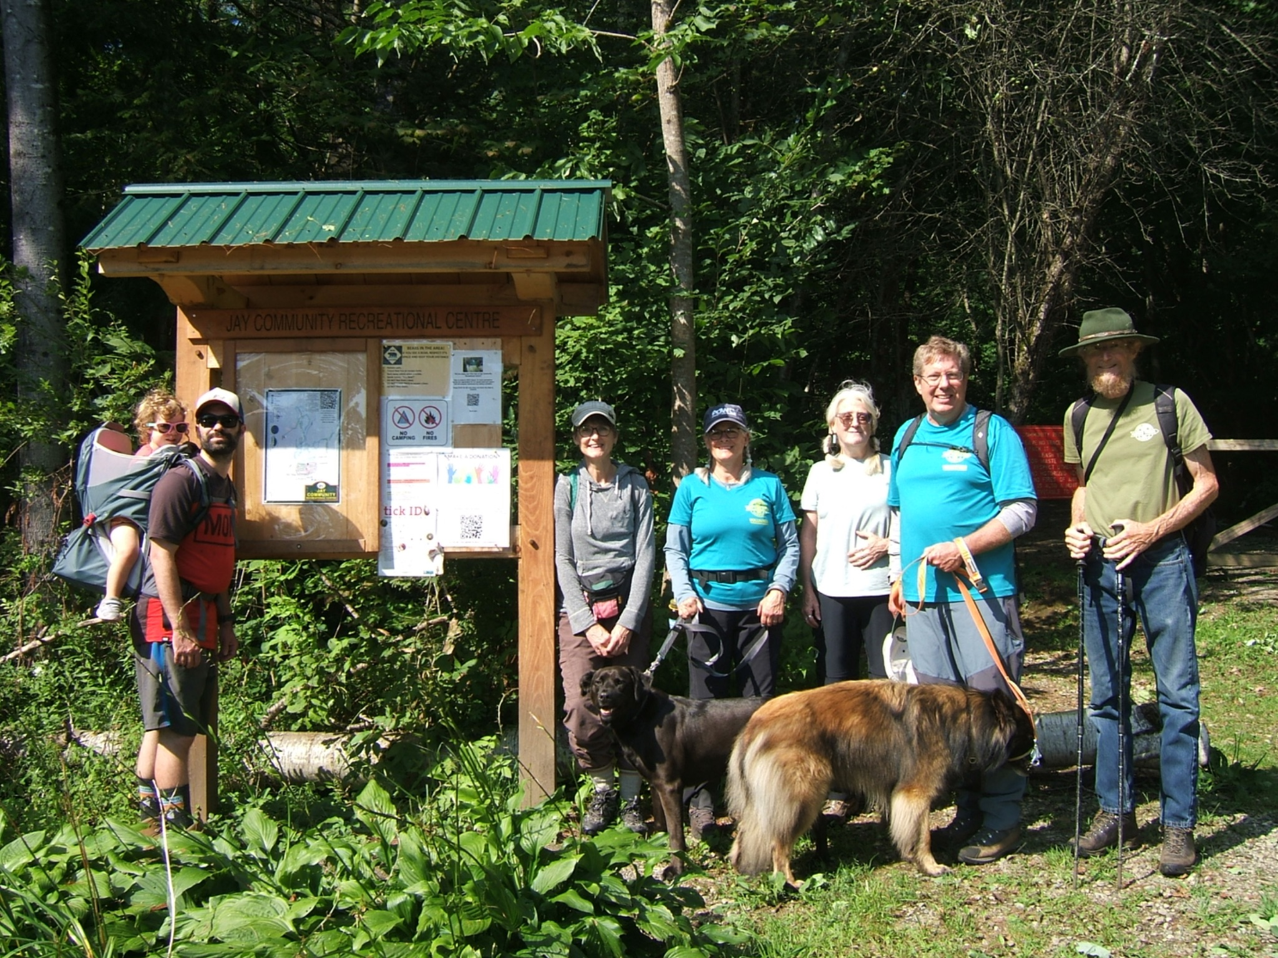

Our section scheduled eight events last season and two of them (a bike ride and a paddle) were cancelled due to bad weather. However, the rest of our hikes were well attended and fun. In late July, two of us hiked up Mt Norris in Eden. In August, seven of us hiked on the Jay Rec Centre trails and then had a potluck at Jeff and Cathy Miller’s home. Later that month, thirteen of us hiked on the Peter Krusch Nature Preserve trails in Cambridge and nine of us had lunch afterward at Martell’s Restaurant. On September 21st, Long Trail Day, six of us hiked up Belvidere Mountain on the LT. In October, seven of us hiked on the trails at Niquette Bay State Park in Colchester on a windy afternoon. Later that month, seven of us hiked to Devil’s Gulch on the LT and returned on the Babcock Trail. Sketchy weather that morning turned into a beautiful autumn day. Hikes like these are a great way to get outdoors and spend time with fellow hikers. Have you ever thought about leading one of our hikes?

Do you have a certain hike that you’d be interested in sharing with a small group? If so, we’d like you to volunteer and we’ll support you by attending your hike. Please let me know if you’re interested and we’ll welcome your help (we need more volunteers to lead our hikes)! Our outings schedule for 2025 will begin in mid June and go through late October.

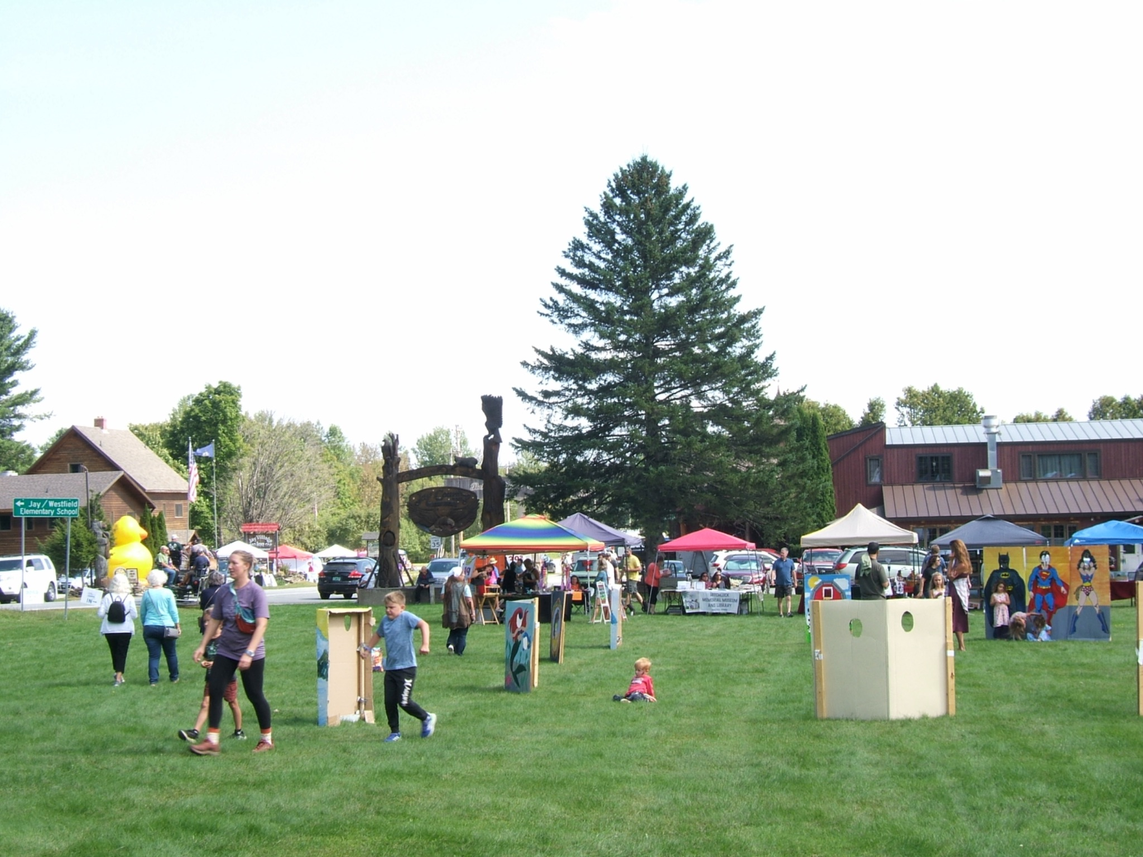

On September 7th, the NFS had a Trail Magic and information table at the Jay Village Oktoberfest. We spoke to lots of folks, who were interested in hiking, about the Long Trail and the GMC. We also passed out brochures and Day Hiker’s Guides to VT. A total of eighteen people signed up to receive our emails and several of them attended our hikes and events during the fall. We look forward to seeing them again on our hikes and volunteer work days!

In September, Luke Sussdorff became the new adopter for Shooting Star Shelter. He’s an avid hiker and trail runner on the LT and other trails. We welcome him to our section and appreciate his volunteer work!

The North Country High School outdoor education program, teachers and students, are the trail adopters of the LT section from Rt 105 to Shooting Star Shelter. Last fall, Don Turner, head of the program, moved out of state and NCHS teacher Ryan Anderson took Don’s place. We greatly appreciate the good work they do on the trail, clearing blowdowns and waterbars each hiking season. Many thanks to Don for his years of volunteer work, guiding students to care for the Long Trail! Thanks also to Ryan; we’ll see you on the trail.

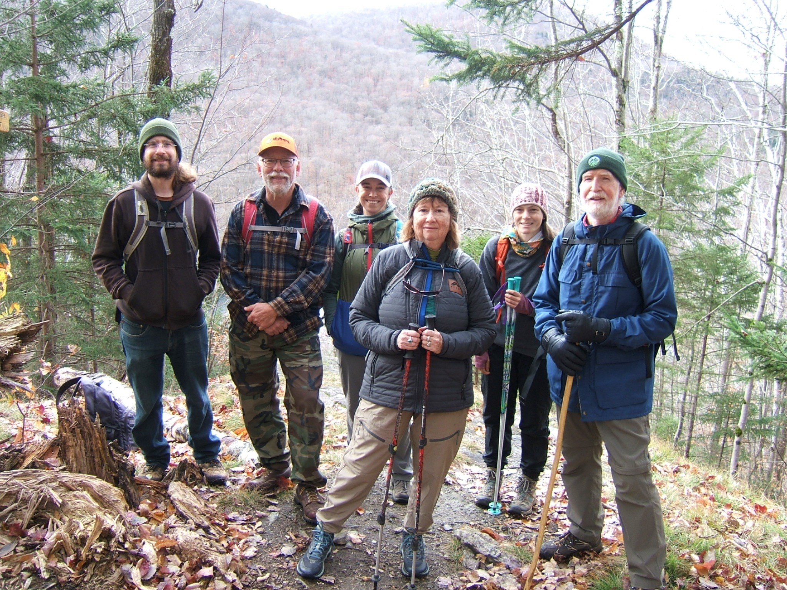

Long Trail Day was a successful fundraising effort for the GMC and the Northern Frontier Section helped raise money on the GMC’s fundraising platform. We formed a fundraising “team” (Northern Frontier) on the platform, like we did last year. People made donations to our team and along with all the other fundraising teams, we raised lots of money for the GMC. Many thanks to all who donated; every donation, large or small really helps!

In 2025, the GMC will review its (and the NFS) governance policies and rules. This includes updating and making changes in the structure and function of the GMC Board, Committees, Membership and Section Bylaws. A legal consultant may be hired to help with this and the GMC staff will schedule a meeting for section leaders and officers this spring. The NFS will need to look at our bylaws to see about making necessary changes. We’ll participate in an upcoming survey given by the GMC and I’ll let our officers know as it gets closer.

Trail work next season will include reblazing the section of the LT from Laura Woodward Shelter to Doll Peak (maybe beyond). Jeff and Cathy Miller plan to walk through that area in spring to evaluate what needs to be done. Also, the privy at Jay Camp will need to be moved to the empty crib next spring. Keegan Tierney plans to schedule the GMC Long Trail Patrol for work on the section of trail between Rt 242 and Hazen’s Notch. Last year, he identified a number of areas that need work and he’s chosen some priorities for 2025. Volunteers from our section will be needed for the work and I’ll email a notice when the time comes.

The James P. Taylor Series will begin soon and you can find out more about it on the GMC website, greenmountainclub.org Click on “Education and Events” to register for a zoom event. Some of the presentations are “in person,” too and require travel to see them. The series runs from January through March and has an interesting variety of talks and presentations. It’s definitely with checking out.

Just a reminder for all us volunteers who work on the trail and shelters: After you do your work, submit a volunteer work report by going to greenmountainclub.org and click on “volunteer”, then “volunteer report” and type in your information. When you submit it you’ll receive an email copy right back in your email. Forward this copy to: me, Jeff Miller and Russ Ford (our email addresses are on the officers list). It’s important that we all know what’s being done on the trail.

Many many thanks to all volunteers who work on the trail, the shelters, lead hikes and events, and contribute through their membership in the Northern Frontier Section. Each of you and your hard work is greatly appreciated!

I wish you good hiking and good health this season. See you on the trail.

Happy Holidays and All the Best,

Ken Whitehead - President Northern Frontier Section

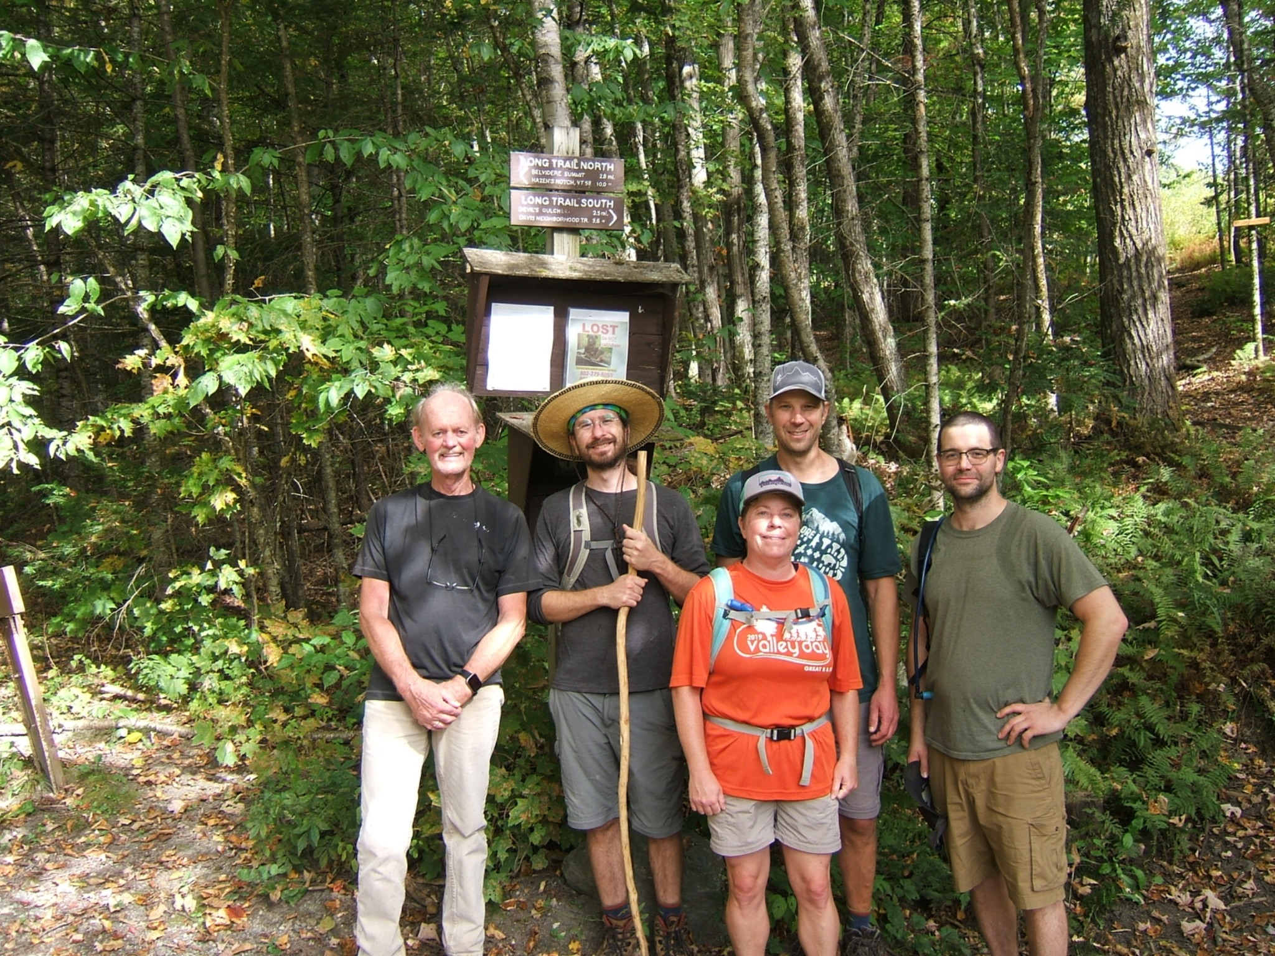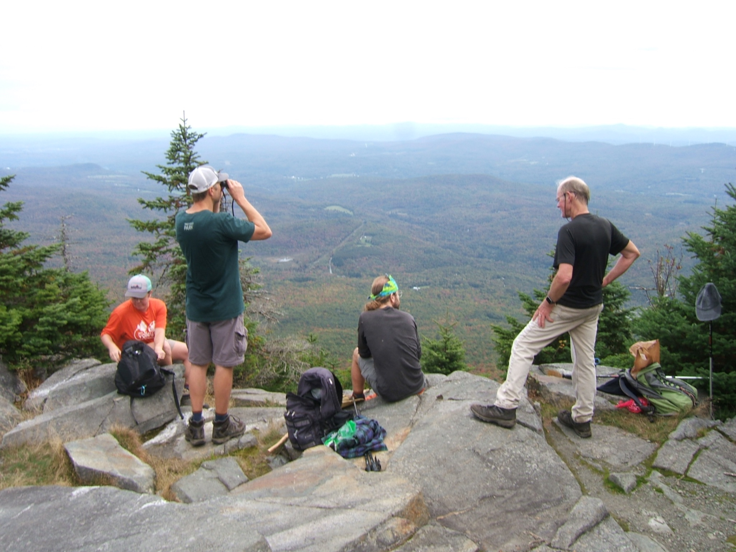

**2025 Winter Events**

| **Sunday, January 12** | Snowshoe/Potluck at the Whitehead’s home.  Enjoy a hike in the Enosburgh Town Forest and bring food to share for a potluck lunch.  Contact Ken at [kenwhitehead.vthiking@gmail.com](mailto:kenwhitehead.vthiking@gmail.com)  or call (802)933-5352. |
| --- | --- |
| **Saturday, February 1** | Snowshoe hike to Shooting Star Shelter from Rt 105 (North Jay Pass). A moderate hike, about 4 miles round trip, 450’ ascent.  Contact Brooks at [brooks24@gmail.com](mailto:brooks24@gmail.com) or call (802)285-2217. |
| **Saturday, February 22** | Hike up Prospect Rock on the Long Trail (near Johnson). An easy hike, about 2 miles round trip, 500’ ascent, with a very nice view from the summit. Have lunch afterwards at Jenna’s Cafe in Johnson. Contact Ken at [kenwhitehead.vthiking@gmail.com](mailto:kenwhitehead.vthiking@gmail.com) or call (802) 933-5352. |
| **Saturday, March 15** | HIke the Jay Recreation Centre Trails. Contact Jeff and Cathy at [mill48@comcast.net](mailto:mill48@comcast.net) or call (802) 528-6785 |
| **Saturday, March 29** | Hike up Haystack Mtn on the Long Trail from Hazen’s Notch. A strenuous hike, about 5.2 miles round trip, 1500’ ascent, a great view from the lookout on the summit. Contact Ken at [kenwhitehead.vthiking@gmail.com](mailto:kenwhitehead.vthiking@gmail.com) or call (802) 933-5352. |

**NFS Officers**

President: Ken Whitehead 802-933-5352 [kenwhitehead.vthiking@gmail.com](mailto:kenwhitehead.vt@gmail.com)

Vice President: Kip Potter 802-868-3125 [pottersvt@comcast.net](mailto:pottersvt@comcast.net)

Secretary: Sharon Whitehead

Newsletter: Ken and Sharon Whitehead

Treasurer: Walter Pomroy 802-635-1770 [wipomroy@gmail.com](mailto:wipomroy@gmail.com)

GMC Board Rep: Kip Potter

Trails: Jeff and Cathy Miller 802-528-6785 [mill48@comcast.net](mailto:mill48@comcast.net)

Shelters: Russ Ford 802-848-7303 [russell.f.ford@gmail.com](mailto:russell.f.ford@gmail.com)

Website: Rolf Anderson 802-326-4799 [rolfanderson@hazensnotch.org](mailto:rolfanderson@hazensnotch.org)

Communications: Brooks Sturtevant 802-285-2217 [brooks24@gmail.com](mailto:brooks24@gmail.com)

Northern Frontier Website [www.gmcnorthernfrontier.org](http://www.gmcnorthernfrontier.org)

-